Wyandot Middle School

Information to help start off a great year!

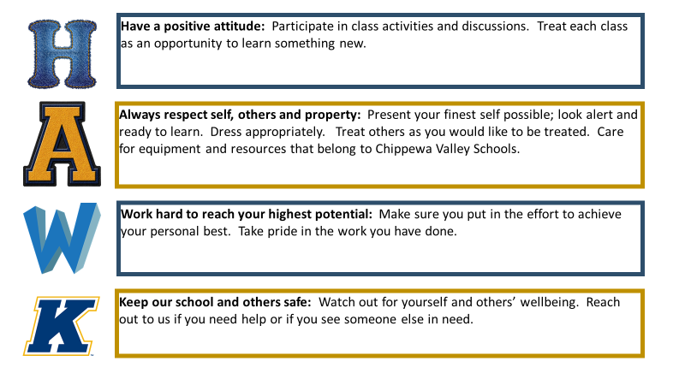
Phone: 586-723-4200
Attendance: 586-723-4299
Principal: Mrs. Christina Kozouz
Asst. Principal: Mrs. Kristin DeLuca
Asst. Principal: Mr. Greg Finlayson

Grade Level Counselors:
6th Grade- Mr. Kline
7th Grade- Mrs. Kelly
8th Grade- Mrs. Thompson

Office Hours: 7:00 AM – 3:45 PM

IMPORTANT DATES (SEMESTER 1):
September 8th – FIRST DAY OF SCHOOL (7:58am - 10:53am) – Teacher PD in PM
September 14th-- 4:00-7:00PM – Materials Pick-Up at Wyandot Middle School (LAST NAMES A-F)
September 15th-- 4:00-7:00PM -- Materials Pick-Up at Wyandot Middle School (LAST NAMES G-P)
September 16th-- 4:00-7:00PM -- Materials Pick-Up at Wyandot Middle School (LAST NAMES Q-Z)
November 3rd-- NO SCHOOL
November 6th-- END OF FIRST QUARTER
November 11th-- Virtual Parent/Teacher Conferences
November 12th--10:53AM Dismissal – Virtual parent/Teacher Conferences
November 13th – 10:53AM Dismissal
November 25th-27th – Thanksgiving Break
December 22nd -- Holiday Break begins (FULL DAY)
January 4th – Classes Resume
January 12th -- EARLY DISMISSAL
January 18th – NO SCHOOL in observance of MLK Day
January 22nd -- EARLY DISMISSAL (end of second quarter)

