6th Grade Supply List Wyandot Middle School 21-22
The following is a list of suggested supplies that your child will use throughout the year.
- 3 dozen or more sharpened pencils. Keep a few at home.
  - Because of moving class to class, you’d be surprised how many pencils go missing! More is better, and to get them on sale in summer is best!
- 5- Pocket folders (poly kind recommended)
  - (1 for ELA (with prongs); 1 for Social Studies (with prongs); 1 for Science; 1 for each exploratory/specials class)
- 1- notebook for ELA
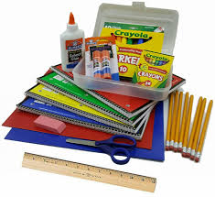
- 1- 1” binder for math
- 2 -notebooks for math
- 1 zippered pencil pouch
- 2 pens; any color
- 5-highlighters (assorted colors)
- 4 dry erase markers (any colors)
- 1 pkg. colored pencils or crayons

Supplies to go to homeroom/1st hour teacher
- 2 Boxes of Kleenex
- 1-2 hand sanitizer
- 1-2 container(s) Clorox Wipes

Class Supplies normally shared that could be purchased to limit sharing
- Ruler
- Scissors
- Calculator (non-graphing)
- Ear buds

