2019-20 THIRD QUARTER NEWSLETTER

WYANDOT MIDDLE SCHOOL
39490 GARFIELD ROAD
CLINTON TWP, MI 48038
Principal, Christina Kozouz (586) 723-4200 Office
Assistant Principal, Kristen DeLuca (586) 723-4201 Fax
Assistant Principal, Greg Finlayson (586) 723-4299 Attendance Line

Dear Wyandot Families,

The new semester brings the opportunity for a fresh start for both students and staff. One of the mottos in our H.A.W.K. student acronym is to “Work hard to reach your highest potential.” We believe that hard work up front pays off later. The third quarter allows students the opportunity to gain perspective and move in a positive direction in each of their classes. There’s a new slate for them to begin and my hope is to see each of our students grow to accomplish great things by the end of the year. Student Report Cards will be sent home with students on Friday, January 31st. Please take some time to review these with your students and acknowledge their accomplishments and/or identify areas to improve on.

Our staff recently did a PBIS (Positive Behavior Interventions and Supports) review day. During this time, students reviewed our behavioral expectations. The focus was on the A of our student acronym which states, “Always respect self, others and property.” We are confident that students will take this important message and spread respect and kindness through our school.

On February 4th, students will reflect and monitor previously set goals during our Student Data Portfolio Day. Students in Math and ELA will review their recent Report Cards and set additional goals for the remainder of the year. By setting goals, we hope that all students understand the importance of committing to something and putting in the work to make it happen! The next step in this process will be completing their Spring NWEA testing which will begin in March.

We hope to see you at the annual Peter Dubon Dodgeball Tournament that will take place on Friday, February 7 at 6:00 PM. It always proves to be a fun night for families supporting a great cause.

Here are a few additional important dates for 3rd Quarter:
2-14 Dismissal at 10:50
2-17 Mid- Winter Break
2-24 Classes Resume
3-11/12 Parent Teacher Conferences 5:30 – 8 PM
3-13 Dismissal at 10:50
4-3 Dismissal at 10:50
4-6 Spring Break
4-13 Classes Resume

Here’s to a great second semester for us all!

Christina Kozouz
Proud Principal

FROM THE DESK OF WYANDOT ADMINISTRATORS . . .

Parents/Guardians, below are a few quick reminders about student expectations and procedures at school.
- Spectator Eligibility/Expectations for Games: Attendance at games is a privilege. To be eligible to attend after-school events, students must not have excessive tardies, may not be on the N & U list, and may not have any suspensions. Eligible students will receive a hand stamp to enter the game. Students are expected to remain in the building and go to the gym directly after school to attend sporting events. Students MAY NOT leave and return for any reason (unless supervised by a parent/guardian).
- Tardy Policy: Classroom attendance and punctuality is directly related to academic success. Students will be issued consequences when excessively arriving late to class. Students will be issued an after-school detention for their 5th and 10th tardy in any one class period, hours 2-5. Students will be issued an in-school suspension on their 15th tardy in any one class period and a meeting with parents/guardians will take place to create a plan for student success.
- Student Behavior/Step Plan: Teachers can assign a “step” to students in the classroom for behaviors that include, but are not limited to poor guest teacher reports, disrespectful/disruptive behavior, insubordination, and not following the school code of conduct. Students will be issued a detention at step 4 and may receive detentions/school suspensions at steps 5 and above.
Please contact Mrs. Kozouz, Mrs. DeLuca, or Mr. Finlayson if you have any questions regarding these procedures.

STUDENT DROP OFF/PICK UP
Thank you for your cooperation with our morning drop-off routine. Student drop off/pick up should not occur in our neighboring business lots. Students can get here early and drop off at curbside with minimum wait if we use the entire available curb to drop off.

We have also noticed an increase in concerning driving at pick up. Please abide by our expectations to ensure the safety of our students!

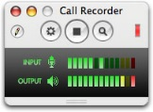ATTENDANCE PROCEDURES
For every absence, the student’s parents/guardian must call the Wyandot Attendance Line (586-723-4299) as soon as possible, explaining the reason for the absence. We prefer this information called and reported to the attendance line by 9:00 a.m. Students arriving late to school should also report to the office for an attendance slip.

Please note that homework requests may be called in after your child has been absent for 3 days or more. Please request homework by 9:00 a.m. using the school’s main office number: (586) 723-4200 to submit your request.

Early Dismissal Procedure

If you find it necessary to pick up your child earlier than regular dismissal time, please
notify the school office by written notice. State the time you need your student to be in the office and who will be picking him/her up. Please remind your child to bring the note to the main office before the start of the school day he/she is to leave early and pick up an early dismissal pass. We understand that unexpected appointments are necessary. If, however; you know that you will pick your child up early, we have found the above practice to be highly successful. Your child is waiting for you in the office. You will not be detained in the event that their class is in a lab or your child is in gym and needs to change clothes.

If your child becomes ill during the school day, he/she may call you to pick him/her up.

Parents must come into the office with picture ID to sign out their student.

Wyandot’s Tip Hotline!
Wyandot has our own “Tip Hotline” for anyone to anonymously report any forms of harassment, bullying, vandalism…that they might be aware of in our building. Simply call 723-4399 to report your information on an answering machine. Our hope is that this procedure will help keep our school safe, clean and enjoyable for everyone.

Parents, would you like to send your 8th grader off to high school with warm wishes and good luck? Well, this is the opportunity you have been waiting for! Include a message (with or without a picture) for your child in Wyandot’s 2019-20 yearbook! Please grab a form from the office or have your student pick one up from Mrs. Gekiere room 213. Space is limited, please turn in ASAP!

Social Media and School

Often times students and families seek the help of school staff when dealing with online bullying or other internet issues. Sometimes students are approached electronically by strangers who try to communicate with them or meet them. These situations can be quite scary for children.

The Macomb County Sheriff’s Office has created a department specifically to deal with computer related crimes and issues. The department is called M.A.C.E. (Macomb Area Computer Enforcement). We often recommend to students and families to contact M.A.C.E. with their online issues. M.A.C.E. works directly with schools for student education and prevention, so they are well aware of the latest online trends and issues affecting our children.
M.A.C.E. (586) 469-5151

2020 GEOGRAPHY BEE CHAMPION

WINNER IS . . .

RJ Gurunian

This Photo by Unknown Author is licensed under CC BY-SA
Congratulations

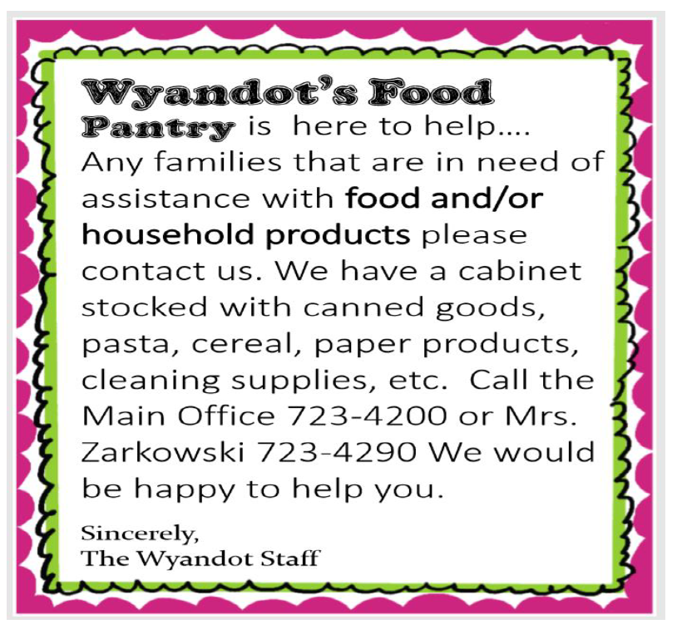
Students of the Month
October 2019
Last Name | First Name | Teacher
Al-Sammarraie | Aiham | Laclave
Ballard | Alexandria | Pedrotti
Baron | Ella | Focht
Brown | Amaya | Anderson
Brown | Daniia | Walczak
Bucanovic | Alina | Elias
Bulgrin | Kenny | Moceri
Cao | Angelina | Harris
Carson | Joey | Skawski
Chatman | Mauriah | Donnenwerth
Chenault | Karma'del | Sheridan
DeWaele | Eric | Harris
Dunn | Emma | Myers
Ensworth | Jacob | Anderson
Escudero | Paolo | Elias
Farmer | Sabrina | Pemberton
Farrell | William | Lietaert
Fett | Addison | Palazzolo
Hollifield | Malik | Evanson
Jachura | Klaudia | DePoorter
Joyner | Evan | Bickers
Juarez-Ortiz | Abriana | Bobzin
Karges | Rorie | Skawski
Kinslow | Tyler | Bickers
Kosanke | Michael | Palazzolo
Kulla | Andi | French
Leitch | Aubree | Moceri
Licari | Grace | Thompson
Students of the Month
October 2019
(continued)
Last Name | First Name | Teacher
Livi | Mia | Laclave
Maciejewski | Makenzie | Evanson
Miller | Emma | Lietaert
Licari | Grace | Thompson
Mosley | London | Knuckles
Najm | Marvin | Gorgioski
Odum | Robynn | Knuckles
Paa | Abbeygail | Orton
Piercey | Sarah | French
Porter | Landon | Donnenwerth
Pulkovski | Annabel | Herberholz
Randazzo | Anthony | Dancel
Robinson | Cornell | Knuckles
Ross | A'Shanae | Herberholz
Sakarya | Lorans | Walczak
Serleen | Elias | Gorgioski
Sitto | Donovan | DePoorter
Simpson | Jaden | Pedrotti
Szerszen | Steven | Focht
Tabone | Anthony | Myers
Trammell | Gavin | Pemberton
VanHollebeke | Evan | Bobzin
Watson | Brandon | Sheridan
Williams | Evan | Sladkin
Wilson | Ryan | Orton

Students of the Month
November 2019
First Name | Last Name | Teacher
Jackson | Ammouri | Pease
Ashlyn | Bagwell | Elias
Shelby | Balten | Harris
Mikaela | Battles | Demaris
Bianka | Bojovic | Demaris
Stephanie | Brouwer | Focht
Tyra | Burks | Gekiere
Josue | Calderon | Darling
Leah | Carpenter | Lietaert
Jake | Clay | Moceri
Taye | Davis | Pemberton
Sara | Dedischew | DePoorter
Delanie | Deegan | Walczak
Endrit | Preci | Gorgioski
Samantha | Fessenden | Sanchez
Jason | Foster | Dancel
Riley | Forster | Sheridan
Rashad | Franklin | Sanchez
Juliano | Haddad | Elias
Kylie | Hardy | Mueller
MyKenzi | Harris | Moceri
Hannah | Hassan | Bobzin
Miranda | Hinton | Donnenwerth
Anna | Kadrovach | Pemberton
Nathan | Leach | Laclave
Grace | Licari | Bickers
Paloka | Ljucovic | Harris
Jack | Maloney | French
Martina | Marku | Donnenwerth
Students of the Month
November 2019
(continued)
First Name | Last Name | Teacher
Mackenzie | Martin | Evanson
Andrew | Moncrief | Thompson
Teiara | Montgomery | Walter
Cheyenne | Morris | Bickers
Tim | Newsome | DePoorter
Mikayla | Nichols | Darling
Jack | Petroske | Mueller
Caradee | Poisson | French
Landon | Pokorski | Knuckles
Andrew | Poxon | Focht
A'Shanae | Ross | Vigiletti
Olivia | Ruthenberg | Mueller
Riley | Sarafian Ballard | Walczak
Jacob | Serra | Pedrotti
Jaden | Simpson | Sheridan
Donovan | Sitto | Walter
Anija | Smith | Pease
Kennedy | Stabnick | Pedrotti
Nevaeh | Stoutermire | Knuckles
Sara | Swartz | Laclave
Chetera | Tankersley | Muller
Arthur | Tendo | Bobzin
Connor | Tesch | Lietaert
Mekayla | Whaley | Gekiere
Jacob | Zoura | Gorgioski

Students of the Month
December 2019
First Name | Last Name | Teacher
Emily | Adamick | Elias
William | Adams | Bobzin
Volodymyr | Baranets | Orton
Semaj | Beasley-Lancaster | Bickers
Justice | Bonner | Orton
Brendan | Bowers | Lietaert
Shayla | Brantley | Myers
Isabella | Bunnell | Pemberton
John | Burney | Sanchez
Maiya | Carter | Darling
Jaiele | Embry-Ruffin | Palazzolo
Zarreia | Fomby | Anderson/Palazzolo
Adriana | Francis | Moceri
Isabella | Fruciano | Bickers
Frances | Goodrich | Lietaert
Emelia | Green | Pedrotti
Dani | Hanna | Gorgioski
Madya | Hannah | Donnenwerth
Aiden | Hardy | Elias
Kylie | Hardy | Pease
Robert | Hopkins | Myers
Evan | Hosey | Sheridan
Melisa | Hoxha | Gorgioski
Angjelina | Juncaj | Skawski
Martyna | Klimecki | Gekiere
Joshua | Kosanke | Pease
Andi | Kulla | Evanson
Blake | LaFontaine | Pease
Mia | Livi | Sheridan
Student of the Month
December 2019
(continued)
First Name | Last Name | Teacher
Lanie | Lutteke | French
Julissa | McDuffey | Bobzin
William | Mickles | Knuckles
Zachary | Neeman | Moceri
Olivia | Niewolak | Walter
Alex | Noble | DePoorter
Tabetha | Olszewski | Darling
Owen | Pemberton | Hilton
Megan | Pickett | Evanson
Kadra | Prinzi | Walczak
Tatyana | Ramey | Pemberton
Vivian | Scalici | Focht
Norah | Shields | Pease
Chloe | Sidote | DePoorter
Vanessa | Sikorski | Donnenwerth
Sofia | Smiljanic | Laclave
Randy | Spitler | Knuckles
Olivia | Swartz | French
Stephanie | Szparaga | Walter
Christian | Szpynda | Walczak
Aidan | Thomas | Laclave
Tyler | Trammell | Pedrotti
Jack | Wade | Sanchez
Devin | Warnock | Skawski
Brooklyn | Watson | Focht
Nala | White | Gekiere
Cody | Young | Anderson
Jackson | Zech | Thompson
FROM THE CLINIC:

Just a reminder….Cough drops, eye drops, and antihistamines must be secured in the office clinic with a Parent/Guardian signature on file. Students should not ‘store’ these types of medications in their lockers or pockets.

Additionally, with the cold and flu season upon us, please help encourage your student to cover their cough and to wash their hands often. These are the two top ways to prevent the spread of illnesses.

Please keep in mind, that if your student has had a fever, or symptoms such as vomiting or diarrhea, or has had a temperature in the last 24 hours, we ask that you keep them home until they are symptom free. This is a recommendation from the Health Department. If they have symptoms lasting more than two days, a doctor visit is recommended.

Communicable Condition Hi-Lights
Pink eye is highly contagious and isn’t always pink! It usually begins with drainage that is visible in the morning upon waking up. Eyes may feel ‘sticky’ and may burn, eventually turning red and teary. If you notice these symptoms in your student, please contact your child’s doctor for an appointment. This is a communicable illness and spreads from person to person very easily. For that reason, a doctor’s note is required with a date of return for your student in order to be allowed back into their daily class schedule.

Lice is a highly contagious condition that requires immediate treatment(s). It is recommended that you check your child monthly during these cold months, especially if your student is vigorously scratching their scalp and behind ears. Treatments can be purchased at most stores, and are effective when the enclosed directions are used and followed.

The most tedious task is using the nit comb and removing all the nits visible. Students must be ‘nit free’ in order to return to school. A doctor note is NOT required for this condition in majority of cases. A second treatment is strongly recommended to destroy any remaining eggs. Use bright lighting and take the time to comb out the attached remaining eggs. Otherwise, these ‘nits’ will hatch within seven day of the first treatment. A second treatment, seven days later is always recommended.

Sprays are also available in most stores that are effective and are used on car seats, furniture, beds, carpet. (sold next to the lice kits)

Pillows and any stuffed animals, cushions, or very large blankets can be double bagged in large trash bags and put outside for 48 hours to destroy infested articles that are too big or bulky for washing machines. All items that can be put in the washing machine need to be thoroughly washed. Don’t forget the hair brushes, combs, hats, ear muffs, hoods, coats, towels.

Vacuum bags need to be disposed of after vacuuming and replaced with new bag.

Additional info can be found on the local county health department website. www.macombcounty.gov

All suspected cases are kept confidential.
Gail O’Connor, Health Aide, 723-4209

LEGO ROBOTICS
The LEGO Robotics competition will be held on Friday, March 13, at Iroquois Middle School from 6-8PM.

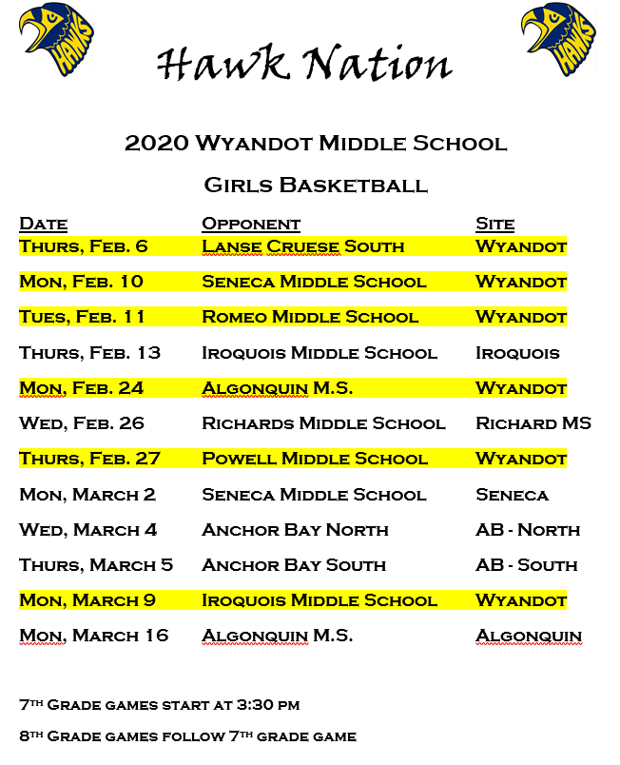

Attention All 8th Grade Parents: Chippewa Valley High School will be hosting an informational meeting to help educate parents on the scheduling process and help make a smooth transition to the High School. The meeting is scheduled for Wednesday, February 26th at 6:00 p.m. in the Chippewa Valley High School Auditorium (just inside Entrance A). Topics covered will be: learn how NWEA test scores are used in the scheduling process to determine your son or daughters class placement, graduation requirements, attendance policy, getting involved in clubs & athletics, and academic help available. An opportunity for questions and answers will also be provided. The meeting lasts about an hour.

Immediately following the 8th Grade Parent Meeting there will be a short presentation regarding AP World History. Information and expectations about this higher level course will be shared for those interested parents.

Parents are then encouraged to attend the Chippewa Valley High School Curriculum Fair that will run from 6:00- 8:00 p.m. This is an opportunity to visit with departmental representatives to learn about their programs and see what CVHS has to offer for course selections.

We hope to see you there!

Chippewa Valley High School 9th Grade Guidance Counselors:
Mrs. Debbie Wall, Mrs. Jennifer Frohock, & Mrs. Nadia Given

Our 9th annual Peter Dubon Dodge Ball Tournament will be held on February 7 starting at 6pm. Students wishing to play need to turn in team registration forms to Mrs. Myers. People wishing to attend the tournament are being asked to donate $1 at the door. All the proceeds will go to the American Cancer Society.
Citizen Advisory Committee
(CAC Meeting)

9AM

Thursday, March 19
Thursday, May 21

SPRING PICTURE DAY REMINDER!

Wednesday, March 25

If you want your child to have his/her picture taken, please make sure that on Picture Day you have filled out the photo envelope enclosing a payment to Lifetouch. The envelope will serve as a “pass” allowing your student to leave class. (Photo envelopes will be available sometime in March.)

ONLY those students who are paying for portraits will get their pictures taken!

Title I Support for Students

Wyandot Middle School recently qualified and received funding through federal Title I grant money to support students that are struggling in classes. Title I funds are used to fund several items including but not limited to:

- after school extended day programs in math and reading for struggling students in all grades;
- pull out support in math and reading offered by Title One Program Specialists; and
- support within classrooms for students at-risk in math and reading.

Title I support originated under the leadership of former president Lyndon Johnson when the Elementary and Secondary Education Act was implemented. That is when the federal government began to allocate funding to help diminish the achievement gap between various groups of students within our country. Since that time there have been many amendments to the act, with the most recent being the No Child Left Behind amendment initiated by President Bush.

Elsewhere in this newsletter you will find the parent involvement policy that our school abides by as well as the Parent-Student-School Compact supporting our schools efforts while we work toward 100% student proficiency in math and reading. It takes the student, school and home working together to achieve this ambitious effort. Please take some time to read the policy and compact in order to see how you can help us reach the goal! Your help is critical to our success.

Parent Involvement Policy

Chippewa Valley Schools’ Title I Parent/Guardian Involvement

Chippewa Valley Schools strongly encourages and welcomes the involvement of parent(s)/guardians(s) in all of the district’s educational programs. It is recognized and appreciated that parent(s)/guardian(s) are the “first teachers” of their children, and that their interest and involvement in the education of their children should not diminish once their child enters the schools of the District. By the adoption of this policy, and with the approval and support of the Board of Education, it is understood that the administration shall design a program/plan that will encourage parent(s)/guardian(s) participation that may include, but not be limited to: the development and review of instructional materials; input on the ways that the district may better provide parent(s)/guardian(s) with information concerning current laws, regulations, and instructional programs; and district offerings of training programs to instruct parent(s)/guardians(s) how to become more involved in their child’s educational programs.
The Parent Involvement Policy will be reviewed annually and modified to reflect current input from the Parent Committees as they represent the parents within their school communities. Pursuant to state law, all parents/guardians will receive a copy of the district’s annual parent involvement plan.

Title I Programs

In accordance with the requirement of the No Child Left Behind Act, the Chippewa Valley Schools Board of Education encourages parent(s)/guardian(s) participation in Title I programs. Parent(s)/guardian(s) shall be offered substantial and meaningful opportunities to participate in the education of their children by this policy.
The board directs that the following actions be implemented by the administration to insure compliance with federal law and to invite parents to become highly involved in the education of their children:

- The involvement of parent(s)/guardian(s) in the planning, implementation, evaluation, and improvement of Title I programs/services through participation on building School Improvement Teams;
- Invitations to parent(s)/guardian(s) to attend at least one annual meeting for Title I parents, with additional meeting opportunities being available as needed, designed to provide Title I information and program services, and to solicit parent(s)/guardian(s) suggestions on program development, planning, evaluation and operation;
- Assistance to parent(s)/guardian(s) in understanding Title I, including the providing of information in a language understandable to the parent(s)/guardian(s) if practicable;
- Parent(s)/guardian(s) notification of Title I criteria for service provision;
- Information on how to be informed of child’s achievement and progress;
- A provision for input by Title I staff at regularly scheduled parent/guardian teacher conferences and any additional communication as requested by the Title I staff or parent(s)/guardian(s)
- Opportunities to enhance parent(s)/guardian(s) capacity to work with children in the home on school learning;
- Professional development opportunities for parents/guardians, teachers, and staff to enhance their understanding of effective parent(s)/guardian(s) involvement strategies;
- Ongoing communication between school and parent(s)/guardian(s); and
- Other appropriate activities (i.e. P.E.N. workshop nights, parent(s)/guardian(s) sessions, family reading/math nights, etc.)
Written Plans/Policies

Chippewa Valley Schools, as a recipient of Title I funds, hereby adopts the following policy statement regarding the development of a district-wide plan for parent(s)/guardian(s) involvement in the development of a Title I plan, and directs the administration to:
- Involve parent(s)/guardian(s) in the development of the plan;
- Develop a plan that provides for the involvement of parent(s)/guardian(s) in the Title I activities of the school;
- Provide the necessary technical, research, staff, and administrative support to schools in the planning and implementing of effective parent(s)/guardian(s) involvement activities to improve student academic achievement and school performance;
- To integrate and coordinate the plans/policies for parent(s)/guardian(s) involvement in Title I programs with parent(s)/guardian(s) involvement in other programs;
- To review and evaluate the District’s plan annually and to share the results of that review and evaluation with the board;
- To assure that the policy/plan contains a compact that outlines how parent(s)/guardian(s), the school staff and students will share the responsibility of improved student achievement; and
- To distribute the district plan to parent(s)/guardian(s) of participating children and to the local community.

Chippewa Valley Schools
Title I Parent-Student-School Compact

This compact pledges our school community to work towards the common goal of having
all students working proficiently!

Parents Pledge: I will…

- Let the teacher know if my child is having any problems in reading and writing
- Let my child know that going to school every day is important for her/his success in life
- Regularly use reading and math materials the school sends home to help my child
- Make it a priority to try and read to my child 20 minutes every day
- Keep handy any information that will help me support my child’s current learning topics
- Use the learning games provided by the Title I grant program weekly and regularly
- Model how reading and math skills impact one’s life every day
- Monitor and limit the amount of time spent watching TV, etc.
- Involve educational games and activities in the daily/weekly routine with my child
Students Pledge: I will…

- Let my teacher and family know if I need help
- Be at school on time each day, unless I am sick
- Read on my own and with my family every day
- Work on my math and reading skills at home
- Use the materials my teacher sends home
- Write down assignments, do my homework every day, and turn it in when it’s due
- Bring home all notes, newsletters, and information I receive from my school
School Pledge: We will…

- Create a partnership with every family in the school
- Monitor student progress and update parents through progress reports, phone calls, email, and newsletters
- Make sure all students get help as soon the need is identified
- Provide appropriate learning materials in reading and math for use in the home
- Explain teaching approaches, expectations, and grading systems to students and their families
- Master our instructional support strategies so that all children can successfully achieve the State of Michigan’s high standards
- Assign work that is relevant and interesting
- Make sure students understand the assignment and what they will learn from it

T-1Parentcompact – 09/10

CHIPPEWA VALLEY SCHOOLS
WYANDOT MIDDLE SCHOOL CALENDAR 2019-2020

NOTE: SEVERAL DIFFERENT DISMISSAL TIMES ON HALF DAYS!
(CALENDAR SUBJECT TO UPDATES)

January 24 End of Second Quarter - half day - 7:56-11:05

January 25 7th/8th Grades - Solo Ensemble @ Rochester High School ALL DAY

February 14 Mid-Winter Break Begins After Student Dismissal - half day - 7:56-10:50

February 24 Classes Resume

March 10 Middle School Students half day – 7:56-10:50

March 11,12 Middle School Students full day
Middle School Parent/Teacher Conferences - Evening only
(by teacher and/or parent request not to exceed the slots available in two 2.5 hour
evening sessions) (5:30-8:00)

March 13 Middle School Students half day - 7:56-10:50

March 19 CAC Meeting – 9AM

March 25 Spring Pictures

April 3 Spring Break Begins After Student Dismissal - half day - 7:56-10:50
End of the Third Quarter

April 13 Classes Resume

April 23 Middle School Students
May 8 & 9 Drama 7:00 @ CVHS

May 7 Middle School Students half day - 7:56-10:50 CHANGED BACK TO A FULL DAY

May 21 CAC Meeting – 9AM

May 25 No School - Memorial Day

May 28 Choir Concert 7:00 @ Dakota High School

June 16 Last Day of School - half day - 7:56-11:05

Our school's vision:
All Wyandot Middle School students will reach their full potential.

Our School's Mission:
The Wyandot community is committed to providing a challenging, relevant, and diverse curriculum in a safe, stimulating environment, enabling each student to become a life-long learner and a contributing member of society.

