**The Pine Knob Student Club Program for the 2022-2023 Season**

We are excited to announce our redesigned student club program.

* 6 consecutive weeks of lift tickets, rentals, and group lessons. (Depending on your club's schedule)
* Pay and register one time for the entire season.

**Here are the Benefits**

1- A six-week lesson program, starting the first week of January and ending the second week of February, that parents register for once up front, like most sports programs that school districts offer. This eliminates the weekly registration, payments, and worrying if there will still be spaces available in the lessons you want. The patch levels are described below.

2- No more overcrowded or canceled lessons.

3- One instructor with the same lesson group all season provides a better learning environment. Students can be placed in another group, closer to their abilities, if necessary. Students may earn several levels of patches depending on their progress.

4- Flexibility to buy just the lift or lift and rental option. Students are limited to what lifts they can use based on what level patch they have. A free evaluation will be available if you are new to the program. Discounted private lessons ($20 off) are available to those who prefer them.

5- Parents can participate in the discounted skiing or riding program on their student club night.

6- Additional tickets and rentals may be purchased with the Student Club Card on any weekday after 3:00 p.m. (non-holidays) at the ticket counter.

**Explanation of the Patch Levels**

The Student Club Program teaches students how to ski or snowboard so they can have fun and be safe participating in a lifelong sport. Students must have specific patches to use certain lifts.

If you want your child to be part of our lesson program you need to sign up now. If your child is new to the program with experience skiing or snowboarding and you don’t choose to do the lesson package they can come to a free evaluation and see what level they are at (Pine Knob will send out a sign up – stay tuned)

If they do not earn the patch they want, they will have to take private lessons to earn more advanced patches or stay on easier runs until they improve and pass an evaluation for a higher patch.

Use the descriptions below to find the next patch level or to decide what level your student is if they are new to the program. It is easy to overestimate your student’s ability, they often regress over the summer and can have problems with new equipment. Just because they have been with you to bigger resorts or have been on all the runs at Pine Knob, this does not mean they will pass their evaluation to use all the runs at Pine Knob. If your student has skied or snowboarded for a long time without lessons, they will most likely need lessons to earn higher patches. They must demonstrate control and the proper technique at each patch level.

**Skiing Patch Levels**

1- Green Patch - is earned by first time skiers when they can stop, link turns together, and use the rope tow. Students will need to use an athletic stance and turn their feet, not their shoulders.

2- Yellow Patch - is earned when students can link turns, turn to a stop, and use the first chairlift.

3- Brown Patch - is earned when students can link turns to a stop, have skis parallel in the second half of the turn, and they can use chairlifts 5 and 6 on Quicksilver.

4- Blue Patch - is earned when students can link turns to a stop and have skis parallel earlier in the first half of the turn.

5- Red Patch - is earned when students can turn on steep slopes, with skis parallel, and using pole touches.

6- Orange Patch - provides access to the terrain parks and can be earned after the red patch or the black patch. They also need to know additional safety points and park etiquette.

7- White Patch - is earned when students can make medium-size parallel turns with pole touches through advanced terrain.

8- **Black Patch** - is earned when students can make smaller-size parallel turns with pole touches through the moguls and on the wall.

**Snowboarding Patch Levels**

1- Green patch - is earned by first time snowboarders when they can make a toe and heel side turn and use the rope tow.

2- Yellow patch - is earned when students can link toe and heel side turns with a traverse and turn to a stop on chair one.

3- Brown Patch - is earned when students can link turns far enough to control speed without a traverse using chairs 5 and 6 on Quicksilver.

4- Orange Patch - provides access to the terrain parks and can be taken after the brown or black patch. Introduction to tricks on the ground, boxes, rails, and jumps. Students learn park safety and etiquette.

5- **Black Patch** - is earned when students can link short and medium radius carved turns on Phase One.

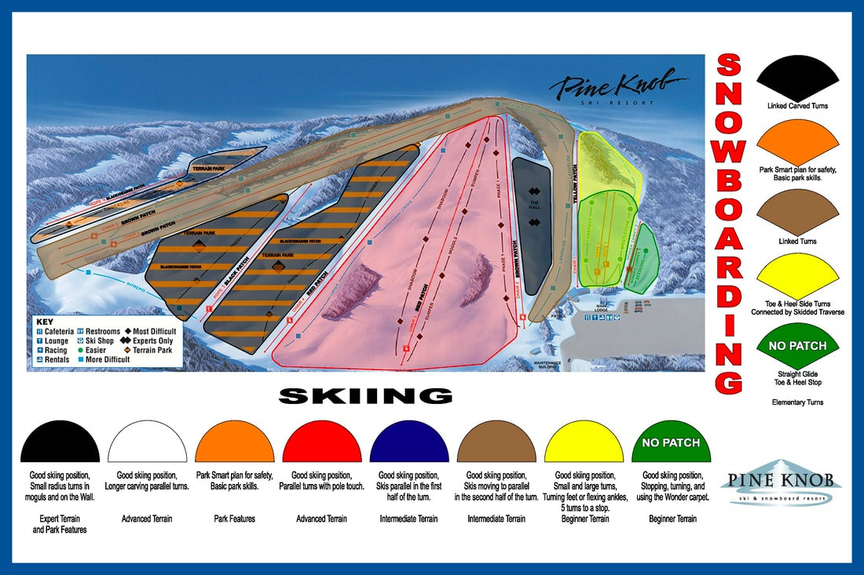

**Student Club Program Details**

1- The Lesson Program starts the first week of January 2023 and will end after the second week of February unless there are makeup sessions due to the resort being closed during the season. Students must be at least 7 years old to participate. **(Seneca is doing an 6-week membership)**

* $210 membership card with 6 student lift tickets
* $180 for rentals (skis/poles/boots OR snowboard/boot)
* $90 for helmet rental
* $180 for 6 one-hour group lessons OR Discounted Private Lessons $65/each

2- Registration starts October 17. Space is limited. We expect the program to fill up quickly, so please register as soon as possible.

3- We recommend signing students up for lessons. We expect them to fill up quickly, and students will be limited to the terrain their current patch allows or the level they are evaluated to be. Students not in the lesson program will need to take private lessons or try to improve on their own and then get reevaluated. Students will be moved to the correct group if registered for the wrong level.

4- Pick up your tickets and rental forms from your sponsor the night your club is scheduled to be at Pine Knob. Sponsors are in the Pinery, which is across from the bar above the rental department. On non-club nights, additional tickets and rentals are available for purchase at the ticket window.

5- Students can earn as many patches as they are able to achieve. Patches are $5 and purchased at the snowsports desk. All patches must be displayed on students for lift operators to see. Patches can be sewn on, or hole punched and put on a key ring or zip tie.

6- Please represent your school well with safe choices, good behavior and kind words!

7- No outside commercial food! Bring a sack lunch from home or purchase food in the cafeteria.

**How to join a Pine Knob Student Club (Registration is limited and closes 12/01/2022)**

Meet with your sponsor to get your club details (follow steps on Seneca’s Ski Club website).

Fill out your online registration form. Each family member participating will choose which club, rentals if needed, and lesson package.

On your club's first night you will meet your sponsors in the Pinery which is located on the second floor above the rental department and across the hall from the Off the Wall Lounge.

Pick up student/sibling lift tickets and rentals from your sponsor.

Adults can purchase discounted lift tickets and rentals, if needed, which can be obtained at the resort ticket window with an adult membership card.