Student Permission Form for Seneca Ski & Snowboard Club

**I have read & discussed the Ski & Snowboard Club rules, as found on the Pine Knob website, & Seneca’s Code of Conduct, with my child**

_____________________________________ _____________________

Parent/Guardian Signature Date

____________________________________ _______________________________

Student Signature Homeroom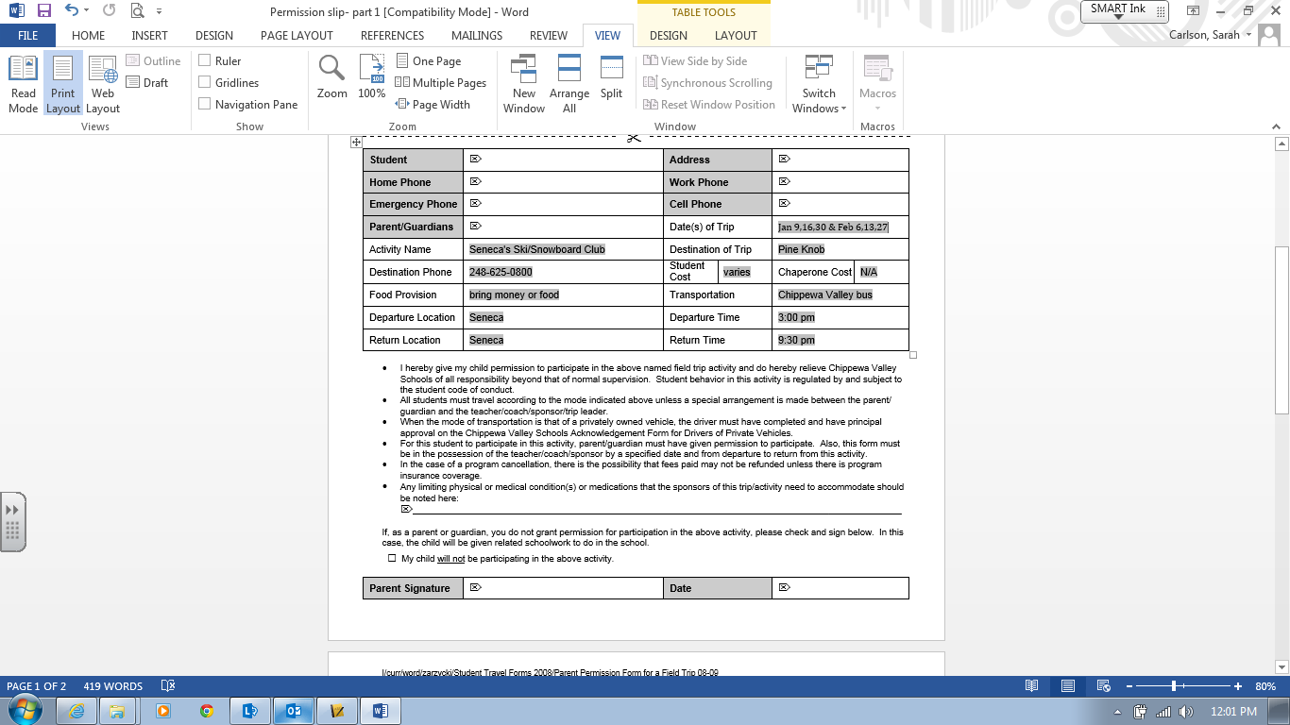 Teacher

. .

. .

**10:00pm**

**Through parent/guardian**

**Jan. 6, 13, 20, 27 Feb. 3, 10, 17, 24**

**\*Bring club membership pass to pick up lift tickets in Pine Knob’s parking lot: 4pm-6pm**