Student Council Holiday Baking Contest

How to enter: Submit a picture of you with your fresh baked holiday creation! You can enter in all 3 categories but can only win once!
One prize will be awarded in each category. Prizes are a custom designed apron, a cookbook, and winter themed cookie cutters. Winners in each category win all three!
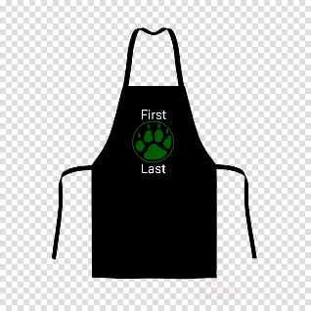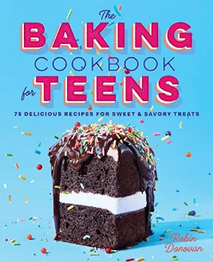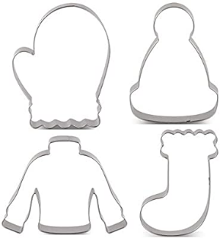
3 Categories: Cake, Cookies, and Gingerbread house.
Entries must be received no later than Friday, December 11th
Send entries to imsstuco20.21@gmail.com
The subject line for the entry is HOLIDAY BAKING CONTEST/ (category of entry). Submit 2 pictures for your entry. One must be a picture of the student with their creation (for verification that it is the student’s creation and not a professional photograph), and another picture of just the cake, cookies or gingerbread house. This second picture will be distributed for schoolwide voting. One entry per category. Entries MUST ALSO INCLUDE student’s name and grade level. Contest only open to current Iroquois Middle School students. Separate entries must be received if competing in more than one category. Students may enter more than one category, but in the event a student earns the most votes in more than one category, they will earn the prize for the category that had the biggest margin of votes between 1st and 2nd place, and the 2nd place winner will be announced as prize winner in the other category.

School wide voting will take place Monday, December 14 through Wednesday, December 16. Winners will be announced on Friday, December 18th.

