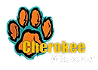
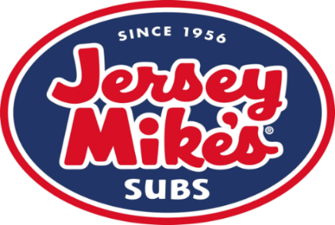

Cherokee Elementary
has teamed up with Jersey Mike’s Subs for a fundraiser!
Nov 7th-Nov 11th
Redeem your Free Sub donation cards at the store between Wednesday, Nov 7th and Sunday Nov 11th, you will receive a free sub of your choice with a minimum $3.00 donation.
You MUST present the donation card to get the deal!!
100% of all donations will be given back to
Cherokee Elementary
So you get to enjoy a delicious sub and support your school!
The FREE SUB donation cards must be redeemed in person in the store. The cards cannot be used for someone not physically in the building. In other words, one donation card per person, per visit
Jersey Mike’s Subs
20813 Hall Rd.
Macomb, MI 48044
586-213-5140

