## 2015-16 THIRD QUARTER NEWSLETTERC:\Users\jgrabowski\AppData\Local\Microsoft\Windows\Temporary Internet Files\Content.IE5\W3QVRT4F\Wyandot_Hawk_Update.jpg

## WYANDOT MIDDLE SCHOOL

39490 GARFIELD ROAD

CLINTON TWP, MI 48038

Principal, Darleen Gauci (586) 723-4200 Office

Assistant Principal, Tony Maniscalco (586) 723-4201 Fax

Assistant Principal, Joe Connolly (586) 723-4299 Attendance Line

Happy 2016!

It is hard to believe that we have completed half of our school year! Soon after you receive this newsletter your WMS student will have received their 2nd quarter report card. If you have any questions or concerns about your child’s grade, make sure to contact your child’s teacher to address your concerns. WMS teachers are great with responding to all parent concerns. Feel free to e-mail them or leave a message on their classroom phone. If you see that your child is struggling in math or language arts there are some seats open in our extended day programs held on Tuesdays and Thursdays after school. There are also open seats for our after school Homework Helper program. You child’s teacher or grade level counselor will be able to provide more information about the best program to suit the needs of your child.

Thank you to those parents who recently completed our 2015-2016 School Improvement survey! Even though the survey window has closed, feel free to contact any administrator to share your concerns. Public schools and school districts need to be constantly working toward continuous improvement of their programs, curriculum and environment. Our district will have an accreditation team visiting February 28 – March 1. The school survey data will be part of the information the team reviews. You can share your suggestions for improvement and concerns via e-mail or phone call to any staff member or you can plan on attending an upcoming CAC meeting where your opinions are always welcomed. The next CAC meeting has been rescheduled to Thursday, February 25, at either 9:00 a.m. or 6:00 p.m. Hope to see you there!

February 10 is a very important day across the state as this is the official **Count Day** which determines the number of students that will be provided funding in our district next fall. The number of students present on count day determines the number of students we will receive funding for; so, it’s important that parents make every effort to have your child in school that entire day. If at all possible, parents should avoid making any appointments between 7:50 – 2:50 on that date. In fact, parents are always encouraged to make appointments after school has ended for the day so learning is never negatively impacted by appointments.

Mark your calendar for Thursday, March 23, when the Chippewa Valley Education Foundation will be hosting its annual fundraiser (tastefest/auction) to benefit CVS students. Stay tuned for more details via school messenger and the district newsletter. You can help by attending or donating items for the auction. Hope to see you there! Tickets will be available in our school’s main office.

Here’s wishing you a restful winter break (no school February 15 – 19) and hoping to see you at upcoming CAC meetings either on February 25 or March 31. RSVP if you plan to attend either the 9:00 a.m. or 6:00 p.m. meeting.

Darleen M. Gauci

***Comments from Connolly***

Social Media and School

Often times students and families seek the help of school staff when dealing with online bullying or other internet issues.  Sometimes students are approached electronically by strangers who try to communicate with them or meet them.  These situations can be quite scary for children.

The Macomb County Sheriff’s Office has created a department specifically to deal with computer related crimes and issues.  The department is called M.A.C.E. (Macomb Area Computer Enforcement).  We often recommend to students and families to contact M.A.C.E. with their online issues.  M.A.C.E. works directly with schools for student education and prevention, so they are well aware of the latest online trends and issues affecting our children.

M.A.C.E. (586) 469-5151

***Early Dismissal Procedure*****

If you find it necessary to pick up your child earlier than regular dismissal time, please

*notify the school office by* ***written notice****. Please state the time you need your student to be in the office.*

**Please remind your child to bring the note to the main office before the start of the school day he/she is to leave early and pick up an early dismissal pass.**

If your child becomes ill during the school day, he/she may call you to pick him/her up.

***Parents must come into the office with picture ID to sign out their student.***

*****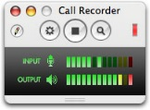ATTENDANCE PROCEDURES***

**For every absence the student’s parents or guardian must call the Wyandot Attendance Line (586-723-4299) as soon as possible, explaining the reason for the absence. We prefer this information called and reported to the attendance line by 9:00 a.m. Students arriving late to school should also report to the office for an attendance slip.**

**Please note that homework requests may be called in after your child has been absent for 3 days or more. Please request homework by 9:00 a.m. using the school’s main office number: (586) 723-4200 to submit your request.**

**STUDENT DROP OFF / PICK UP**

Student drop off / pick up should not occur in our neighboring business lots… the doctor’s office has called about more concerns with erratic traffic from people especially in the morning. Remember folks that students can get here early and drop off at curbside with minimum wait if we use the entire available curb to drop off and again arrive by 7:40 for no wait –

***Wyandot’s Tip Hotline!***

Wyandot has our own “Tip Hotline” for anyone to anonymously report and forms of harassment, bullying, vandalism…that they might be aware of in our building. **Simply call 723-4399 to report your information on an answering machine.** Our hope is that this procedure will help keep our school safe, clean and enjoyable for everyone.

**EMPLOYMENT OPPORTUNITY**

**pe02652_**

The Chippewa Valley Schools Pupil Transportation Department is looking for Substitute School Bus Drivers.  A Commercial Driver’s License with Passenger and School Bus endorsements is preferred; however, unlicensed eligible candidates will be considered and driver development will be made available.

If you are interested in pursuing this exciting and rewarding profession, log on to [www.chippewavalleyschools.org](http://www.chippewavalleyschools.org) and complete an application under the EMPLOYMENT tab.

If you have specific questions, you can call 586 723-2160.



***OCTOBER 2015 STUDENT OF THE MONTH***

|  |  |  |  |
| --- | --- | --- | --- |
| Last Name | First Name | Teacher | Grade |
| Al-Salan | Adeel | Pemberton | 6th |
| Bauer | Truman | Rose Harrison | 6th |
| Bova | David | Sheridan | 6th |
| Cox | Elizabeth | Laclave | 6th |
| Gordon | Dallas | Laclave | 6th |
| Gredelj | Azra | Sheridan | 6th |
| Jankowski | Bella | Alessi | 6th |
| Kulka | Olivia | Alessi | 6th |
| Maguire | Carina | Pedrotti | 6th |
| Merpi | Stella | Pease | 6th |
| Pelkey | Ruthie | Bickers | 6th |
| Samhouri | Saif | Pease | 6th |
| Stachowicz | Aidan | Pedrotti | 6th |
| Thomas | Justin | Roberts | 6th |
| Watanabe | Mary | Ebbole | 6th |
| Zeoli | Dominic | Pemberton | 6th |
| Ali | Breanna | Roberts | 7th |
| Ali | Breanna | Walczak | 7th |
| Armstrong | Connor | Moceri | 7th |
| Arnone | Nathan | Walczak | 7th |
| Ashley | Jonathon | French | 7th |
| Bartlett | Jonathon | Skawski | 7th |
| Bartlett | Jonathon | Roberts | 7th |
| Bogojevski | Antonij | Elias | 7th |
| Dedischew | Adam | Titran | 7th |
| Farmer | Sarah | Moceri | 7th |
| Frederick | Brandon | Ebbole | 7th |
| Kassab | Tanel | Skawski | 7th |
| Klucka | Brian | Donnenwerth | 7th |
| Makarski | Marsella | Donnenwerth | 7th |
| Metti | Eedell | Titran | 7th |
| Nows | Emily | French | 7th |
| Palmer | Brooke | DePoorter | 7th |
| Perry | Guan | DePoorter | 7th |
| Tocco | Samantha | Elias | 7th |
| Aggoubi | Ameer | Roberts | 8th |
| Dinoto | Peter | Sanchez | 8th |
| Fresh | Paige | Hilton | 8th |
| Hurlin | Tyra | Sanchez | 8th |
| Jamu | Sara | Locricchio | 8th |
| Kaci | Aleksandra | Herberholz | 8th |
| Lange | Alyssa | Ebbole | 8th |
| Lulgjuraj | Tommy | Hilton | 8th |
| Lusha | Rebecca | Ebbole | 8th |
| Mackezyk | Patrick | Bobzin | 8th |
| Muhammad | Noor | Kahl | 8th |
|  |  |  |  |
| ***OCTOBER 2015 STUDENT OF THE MONTH (continued)*** | | | |
| Last Name | First Name | Teacher | Grade |
| Petrykowski | Nina | Bobzin | 8th |
| Phinney | Alexis | O'Malley | 8th |
| Plotkowski | Julia | Kahl | 8th |
| Riehl | Collin | Locricchio | 8th |
| Seley | Alexis | Herberholz | 8th |
| Williams | Tyree | Roberts | 8th |
| Winters | Joshua | Koseck | 8th |

|  |  |  |  |
| --- | --- | --- | --- |
| ***NOVEMBER 2015 STUDENT OF THE MONTH*** | | | |
| Last Name | First Name | Teacher | Grade |
| Anderson | Corey | Gekiere | 8th |
| Bierl | Lena | Thompson | 6th |
| Blazejewski | Carao | French | 7th |
| Carson | Michael | Skawski | 7th |
| Clements | Derek | Pease | 6th |
| Clements | Derek | Pemberton | 6th |
| Cox | Elizabeth | Pedrotti | 6th |
| Cudnik | Rose | Walczak | 7th |
| DiMaggio | Lino | Sladkin | 7th |
| Dornan | Megan | Bobzin | 8th |
| Doro | Alex | French | 7th |
| Eickelberg | Gretchen | Gekiere | 8th |
| Frederick | Brandon | Walczak | 7th |
| Garten | Bryanna | Hilton | 8th |
| Hole | Chris | Koseck | 7th |
| Keitz | Julianne | Darling | 6th |
| Kozianowski | Luke | Hilton | 8th |
| Kunnummyalil | Katherine | Moceri | 7th |
| Laudeman | Hunter | DePoorter | 7th |
| Marku | Eduard | Sladkin | 8th |
| McKay | Nicklas | Bobzin | 8th |
| McMillan | Kylie | Moceri | 7th |
| Millsap | Jackson | Moceri | 7th |
| Nagj | Jovana | Pease | 6th |
| Nichols | Michael | Pemberton | 6th |
| Nowicki | Jackson | Darling | 6th |
| Onorati | Danya | Bickers | 6th |
| Pagel | Alex | Sladkin | 8th |
| Pickett | Emily | Sheridan | 6th |
| Pulizzi | Alyssa | Pemberton | 6th |
| Sherman | Kariscent | Laclave | 6th |
| Shyti | Antonela | Skawski | 7th |
| Sykes | Anthony | Thompson | 7th |
| Szpotek | Nikolas | Pedrotti | 6th |
| Thompson | Ethan | Pedrotti | 6th |
| ***NOVEMBER 2015 STUDENT OF THE MONTH (continued)*** | | | |
| |  |  |  |  | | --- | --- | --- | --- | | Last Name | First Name | Teacher | Grade | | | | |
| Varghese | Johan | Depoorter | 7th |
| Veseli | Krist | Sheridan | 6th |
| Whaley | Jack | Darling | 6th |
| Zoura | Jonathon | Laclave | 6th |

MC900133479[1]MC900133479[1]MC900133479[1]MC900133479[1]

MC900133479[1]

Congratulations go out to Griffin Bloch for winning our school-wide ***Geography Bee***. Runners up were James Anderson and Brett Kramer.

MC900133479[1]MC900133479[1]MC900133479[1]

**SPRING PICTURE DAY**

**REMINDER!**

**April 13, 2016**

**8:00 AM – 1:00 p.m**

****

**If you want your child to have his / her picture taken, please make sure that on Picture Day you have filled out the *photo envelope* enclosing a *payment to Lifetouch*. The envelope will serve as a “pass” allowing your student to leave class. (Photo envelopes will be available sometime in April.)**

**ONLY those students who are paying for portraits will get their pictures taken!**

**Your Child Has a Library Card**

As homework ramps up, don’t forget, your child has a wonderful resource to assist in homework help and test preparation—a Clinton-Macomb Public Library card!  At the beginning of the school year all students in Chippewa Valley Schools were issued a library card to the Clinton-Macomb Public Library.  This card gives your child access to online resources such as online homework help, databases for research, use of the library’s public computers, including Office Suite and more.

To access these resources, your child may visit [www.cmpl.org](http://www.cmpl.org) and login using his or her student ID number and the last four digits of the phone number registered with the school for the password.  If you have trouble logging in with the student ID number, it may mean that your child already has an existing card in the library’s system.  If that is the case you will need to login using the library bar code.  If you have questions, feel free to call the library at (586) 226-5020, Monday-Thursday 9am-9pm, Saturday-Sunday 9am-6pm, or Sunday 1-6pm during the school year.  A library team member will happy to assist you with any questions.

***Testing News***

Wyandot Middle School students will be participating in several assessments during the third and fourth quarters including WIDA, NWEA, MI ACCESS and M STEP.

Several Bilingual students will be completing WIDA testing the week of February 22-26. The WIDA test was originally used by three states (**WI**sconsin, **D**elaware and **A**rkansas) to assess English language learners on language acquisition. Since then, the states using the assessment have changed and an acronym was initiated: **W**orld-class **I**nstructional **D**esign and **A**ssessment. Wyandot’s bilingual students MUST complete the WIDA every year until successful completion.

The “M STEP” is the on-line version of state testing, now in its second year, and will be administered. It replaced the former MEAP test that was previously administered in the fall of each school year. MI ACCESS will also be administered to qualifying students as it has been done in the past, BUT it will also be administered on-line like the M STEP. All students will be assessed in both math and English language arts while 7th graders will also take the science test and 8th graders will complete the social studies test. Test results are used both for school accreditation as well as improving instruction for students’ educational success.

It is imperative that students attend school on all of their grade level’s testing days! Math and language arts tests consist of two parts. Since our school is required to test EVERY student on ALL components of each test, we have a very tight schedule for each grade/content/teacher to test at specific times. The testing windows for each grade follows:

|  |  |  |  |  |  |  |  |  |
| --- | --- | --- | --- | --- | --- | --- | --- | --- |
| Grade: | April 13 | April 20 | April 27 | May 4 | May 11 | May 18 | May 25 | June 1 |
| 6th |  |  |  |  |  | TESTING | TESTING | TESTING |
| 7th |  |  | TESTING | TESTING | TESTING |  |  |  |
| 8th | TESTING | TESTING | TESTING |  |  |  |  |  |

Math and language arts will consist of three separate activities administered on three separate days:

* ½ hour classroom activity with the teacher and all classmates
* 1 ½ - 2 hour computer adaptive test administered on line
* 1-2 hour performance task completed on line

Notice that the testing window is adjacent to spring breaks and holidays. Parents should make travel plans accordingly to avoid missing school during your child’s scheduled testing time. Appointments should be scheduled for after school times or on days outside the testing window. As the testing window approaches for your child, they will get an informational sheet with their EXACT testing dates/times.

There are several different types of questions ***AND*** testing tools that our students haven’t seen during the former paper and pencil state tests, but they will see them on the on-line version. While teachers will be sharing this information with their classes, students are still encouraged to complete the practice assessments using the on-line testing tools ***available only through one of these two sites by using Google Chrome:***

<https://wbte.drcedirect.com/MI/portals/mi/ott1>.

<http://aware.22itrig.org/>

If you would like to know more about the state tests, come to our next CAC meeting on February 26 at 9:00 a.m. or 6:00 p.m.

FROM THE CLINIC:

Just a reminder….Cough drops, eye drops, and antihistamines must be secured in the office clinic with a Parent/Guardian signature on file. Students should not ‘store’ these types of medications in their lockers or pockets.

Additionally, with the cold and flu season upon us, please help encourage your student to cover their cough and to wash their hands often. These are the two top ways to prevent the spread of illnesses.

Please keep in mind, that if your student has had a fever, or symptoms such as vomiting or diarrhea, or has had a temperature in the last 24 hours, we ask that you keep them home until they are symptom free. This is a recommendation from the Health Department. If they have symptoms lasting more than two days, a doctor visit is recommended.

Communicable Condition Hi-Lights

Pink eye is highly contagious and isn’t always pink! It usually begins with drainage that is visible in the morning upon waking up. Eyes may feel ‘sticky’ and may burn, eventually turning red and teary. If you notice these symptoms in your student, please contact your child’s doctor for an appointment. This is a communicable illness and spreads from person to person very easily. For that reason, a doctor’s note is required with a date of return for your student in order to be allowed back into their daily class schedule.

Lice is a highly contagious condition that requires immediate treatment(s). It is recommended that you check your child monthly during these cold months, especially if your student is vigorously scratching their scalp and behind ears. Treatments can be purchased at most stores, and are effective when the enclosed directions are used and followed.

The most tedious task is using the nit comb and removing all the nits visible. Students must be ‘nit free’ in order to return to school. A doctor note is **NOT** required for this condition in majority of cases. A second treatment is strongly recommended to destroy any remaining eggs. Use bright lighting and take the time to comb out the attached remaining eggs. Otherwise, these ‘nits’ will hatch within seven day of the first treatment. A second treatment, seven days later is always recommended.

Sprays are also available in most stores that are effective and are used on car seats, furniture, beds, carpet. (sold next to the lice kits)

Pillows and any stuffed animals, cushions, or very large blankets can be double bagged in large trash bags and put outside for 48 hours to destroy infested articles that are too big or bulky for washing machines. All items that can be put in the washing machine need to be thoroughly washed. Don’t forget the hair brushes, combs, hats, ear muffs, hoods, coats, towels.

Vacuum bags need to be disposed of after vacuuming and replaced with new bag.

Additional info can be found on the local county health department website. [www.macombcounty.gov](http://www.macombcounty.gov)

All suspected cases are kept confidential.

Jackie Bahm

Health Aide

723-4209

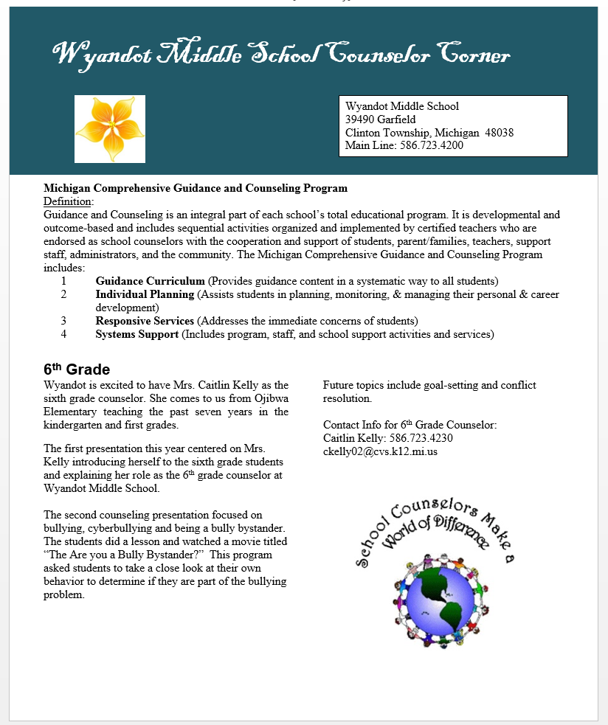

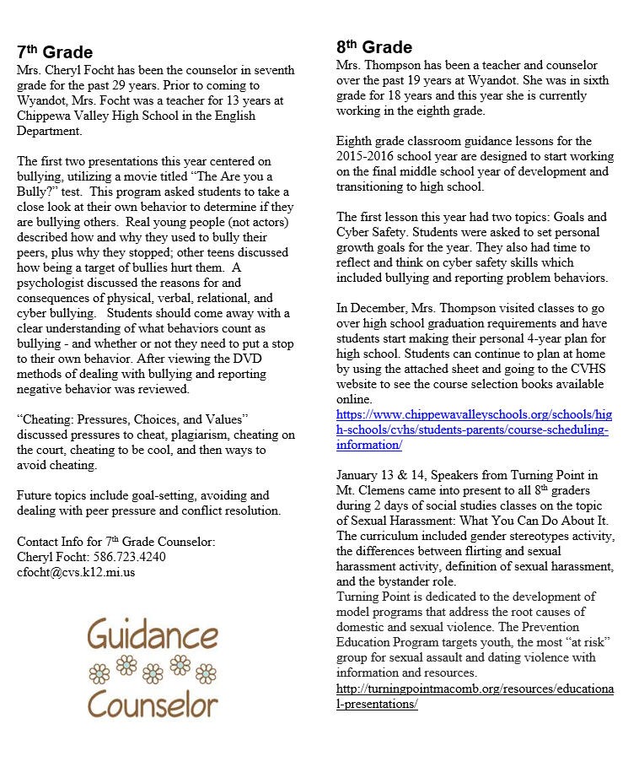





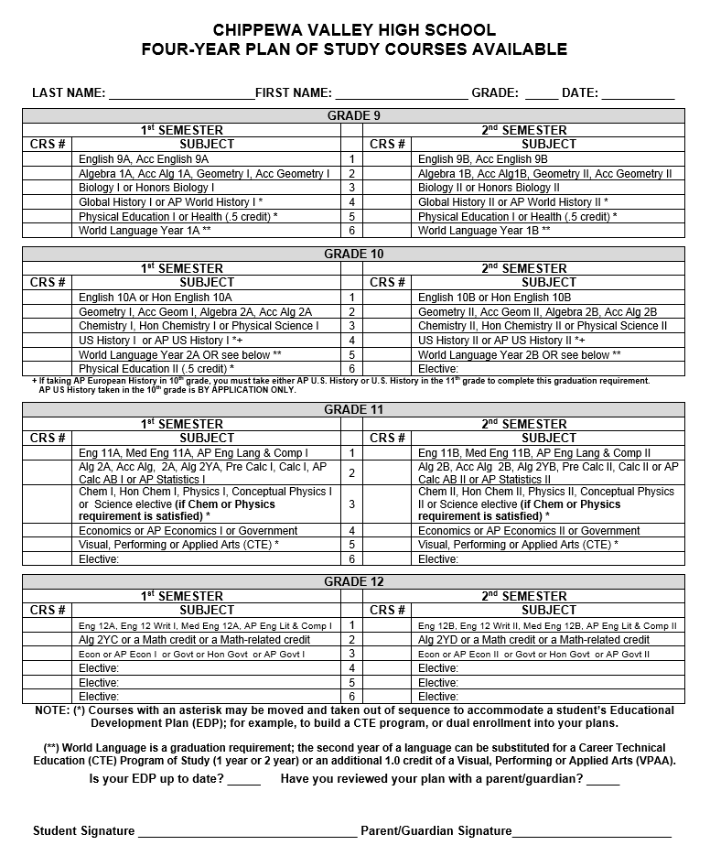

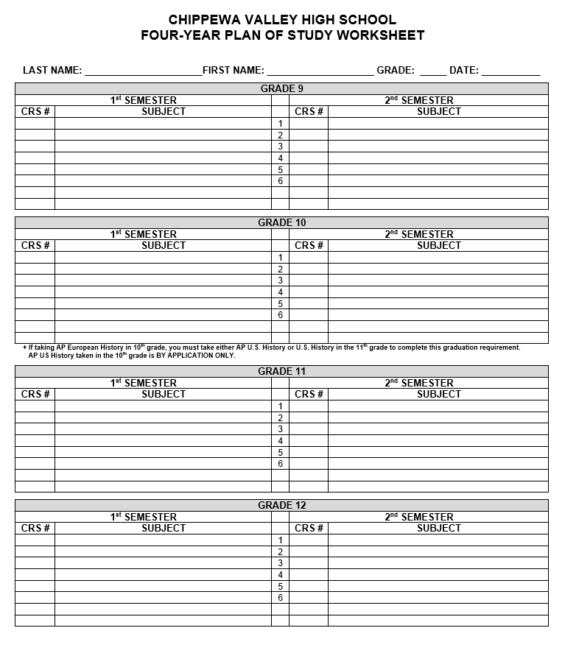

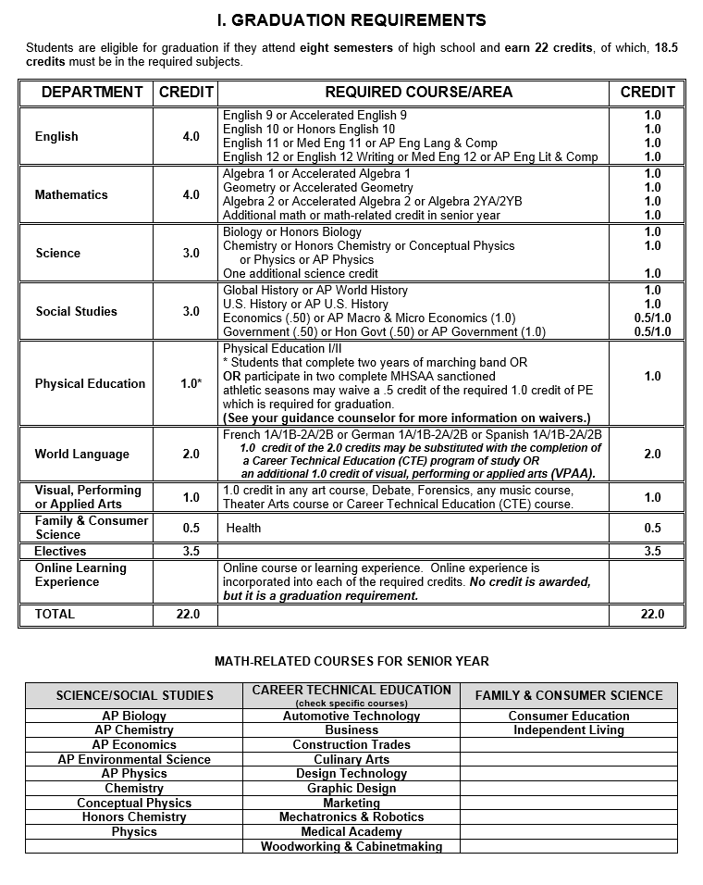

Green School Initiative

Have you ever thought about what you could do to help the environment? Perhaps you have, but the task just seems to be too much for one middle school student.

What if I told you that you could help the environment and you can actually start right here at Wyandot?

Wyandot Middle School is looking for students who would like to be a part of our Green School Initiative by joining our **Wyandot Green Team**. Being a part of the Green Team would mean that you will work with other students and adults to come up with ways to help your environment and also make Wyandot a more beautiful place to be.

As a part of the **Wyandot Green Team**, some of the work you might do could include planning cleanups around the school property, planting flowers or other greenery around your school, organizing recycling drives, and many other activities that you would help organize.

If you think you might like to be a part of the **Wyandot Green Team**, please fill out the flyer that was provided to you from your homeroom teacher. Additional flyers and information are available in the office.

**Title I Support for Students**

Wyandot Middle School recently qualified and received funding through federal Title I grant money to support students that are struggling in classes. Title I funds are used to fund several items including but not limited to:

* after school extended day programs in math and reading for struggling students in all grades;
* pull out support in math and reading offered by Title One Program Specialists; and
* support within classrooms for students at-risk in math and reading.

Title I support originated under the leadership of former president Lyndon Johnson when the Elementary and Secondary Education Act was implemented. That is when the federal government began to allocate funding to help diminish the achievement gap between various groups of students within our country. Since that time there have been many amendments to the act, with the most recent being the No Child Left Behind amendment initiated by President Bush.

Elsewhere in this newsletter you will find the parent involvement policy that our school abides by as well as the Parent-Student-School Compact supporting our schools efforts while we work toward 100% student proficiency in math and reading. It takes the student, school and home working together to achieve this ambitious effort. Please take some time to read the policy and compact in order to see how you can help us reach the goal! Your help is critical to our success.



Parent Involvement Policy

**Chippewa Valley Schools’ Title I Parent/Guardian Involvement**

Chippewa Valley Schools strongly encourages and welcomes the involvement of parent(s)/guardians(s) in all of the district’s educational programs. It is recognized and appreciated that parent(s)/guardian(s) are the “first teachers” of their children, and that their interest and involvement in the education of their children should not diminish once their child enters the schools of the District. By the adoption of this policy, and with the approval and support of the Board of Education, it is understood that the administration shall design a program/plan that will encourage parent(s)/guardian(s) participation that may include, but not be limited to: the development and review of instructional materials; input on the ways that the district may better provide parent(s)/guardian(s) with information concerning current laws, regulations, and instructional programs; and district offerings of training programs to instruct parent(s)/guardians(s) how to become more involved in their child’s educational programs.

The Parent Involvement Policy will be reviewed annually and modified to reflect current input from the Parent Committees as they represent the parents within their school communities. Pursuant to state law, all parents/guardians will receive a copy of the district’s annual parent involvement plan.

**Title I Programs**

In accordance with the requirement of the No Child Left Behind Act, the Chippewa Valley Schools Board of Education encourages parent(s)/guardian(s) participation in Title I programs. Parent(s)/guardian(s) shall be offered substantial and meaningful opportunities to participate in the education of their children by this policy.

The board directs that the following actions be implemented by the administration to insure compliance with federal law and to invite parents to become highly involved in the education of their children:

* The involvement of parent(s)/guardian(s) in the planning, implementation, evaluation, and improvement of Title I programs/services through participation on building School Improvement Teams;
* Invitations to parent(s)/guardian(s) to attend at least one annual meeting for Title I parents, with additional meeting opportunities being available as needed, designed to provide Title I information and program services, and to solicit parent(s)/guardian(s) suggestions on program development, planning, evaluation and operation;
* Assistance to parent(s)/guardian(s) in understanding Title I, including the providing of information in a language understandable to the parent(s)/guardian(s) if practicable;
* Parent(s)/guardian(s) notification of Title I criteria for service provision;
* Information on how to be informed of child’s achievement and progress;
* A provision for input by Title I staff at regularly scheduled parent/guardian teacher conferences and any additional communication as requested by the Title I staff or parent(s)/guardian(s)
* Opportunities to enhance parent(s)/guardian(s) capacity to work with children in the home on school learning;
* Professional development opportunities for parents/guardians, teachers, and staff to enhance their understanding of effective parent(s)/guardian(s) involvement strategies;
* Ongoing communication between school and parent(s)/guardian(s); and
* Other appropriate activities (i.e. P.E.N. workshop nights, parent(s)/guardian(s) sessions, family reading/math nights, etc.)

**Written Plans/Policies**

Chippewa Valley Schools, as a recipient of Title I funds, hereby adopts the following policy statement regarding the development of a district-wide plan for parent(s)/guardian(s) involvement in the development of a Title I plan, and directs the administration to:

* Involve parent(s)/guardian(s) in the development of the plan;
* Develop a plan that provides for the involvement of parent(s)/guardian(s) in the Title I activities of the school;
* Provide the necessary technical, research, staff, and administrative support to schools in the planning and implementing of effective parent(s)/guardian(s) involvement activities to improve student academic achievement and school performance;
* To integrate and coordinate the plans/policies for parent(s)/guardian(s) involvement in Title I programs with parent(s)/guardian(s) involvement in other programs;
* To review and evaluate the District’s plan annually and to share the results of that review and evaluation with the board;
* To assure that the policy/plan contains a compact that outlines how parent(s)/guardian(s), the school staff and students will share the responsibility of improved student achievement; and
* To distribute the district plan to parent(s)/guardian(s) of participating children and to the local community.

**Chippewa Valley Schools**

**Title I Parent-Student-School Compact**

***This compact pledges our school community to work towards the common goal of having***

***all students working proficiently***!

**Parents Pledge: I will…**

* Let the teacher know if my child is having any problems in reading and writing
* Let my child know that going to school every day is important for her/his success in life
* Regularly use reading and math materials the school sends home to help my child
* Make it a priority to try and read to my child 20 minutes every day
* Keep handy any information that will help me support my child’s current learning topics
* Use the learning games provided by the Title I grant program weekly and regularly
* Model how reading and math skills impact one’s life every day
* Monitor and limit the amount of time spent watching TV, etc.
* Involve educational games and activities in the daily/weekly routine with my child

**Students Pledge: I will…**

* Let my teacher and family know if I need help
* Be at school on time each day, unless I am sick
* Read on my own and with my family every day
* Work on my math and reading skills at home
* Use the materials my teacher sends home
* Write down assignments, do my homework every day, and turn it in when it’s due
* Bring home all notes, newsletters, and information I receive from my school

**School Pledge: We will…**

* Create a partnership with every family in the school
* Monitor student progress and update parents through progress reports, phone calls, email, and newsletters
* Make sure all students get help as soon the need is identified
* Provide appropriate learning materials in reading and math for use in the home
* Explain teaching approaches, expectations, and grading systems to students and their families
* Master our instructional support strategies so that all children can successfully achieve the State of Michigan’s high standards
* Assign work that is relevant and interesting
* Make sure students understand the assignment and what they will learn from it

T-1Parentcompact – 09/10

C:\Documents and Settings\jgrabowski\Local Settings\Temporary Internet Files\Content.IE5\V7QVETH7\MC900412816[1].wmfC:\Documents and Settings\jgrabowski\Local Settings\Temporary Internet Files\Content.IE5\GNZ7S8JO\MC900440066[1].wmfC:\Documents and Settings\jgrabowski\Local Settings\Temporary Internet Files\Content.IE5\J08YP50G\MC900191887[1].wmfC:\Documents and Settings\jgrabowski\Local Settings\Temporary Internet Files\Content.IE5\V7QVETH7\MC900021407[1].wmfC:\Documents and Settings\jgrabowski\Local Settings\Temporary Internet Files\Content.IE5\DJM7Y9EM\MC900113476[1].wmfC:\Documents and Settings\jgrabowski\Local Settings\Temporary Internet Files\Content.IE5\GNZ7S8JO\MC900113430[1].wmf

**Please help us help our VETERANS!**

**(Plus earn money for Wyandot students)**

Thanks so much for your generous donations to our clothing, shoes, and household goods bin. *All sizes of any type of clothing are accepted. They even accept ripped or stained clothing, which is sold to recyclers that break it down and reuse it.*

Please continue to deposit any items that you no longer need or want.

Remember, Wyandot students get credit for items deposited!

We receive a check based on the quantity we collect. This year we have been able to put this money toward our printer cartridges so students can continue to enjoy printing out their masterpieces!

***Receipts for tax purposes are available upon request.***

Questions? Please contact Mrs. Titran at wtitran@cvs.k12.mi.us



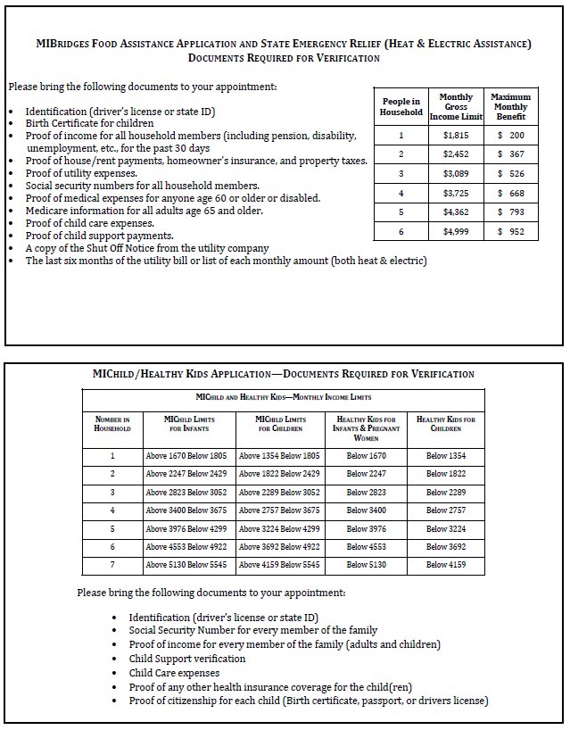

***WYANDOT PHONE EXTENSIONS***



723-4264 Mrs. Alessi

723-4265 Mrs. Anderson

723-4209 Mrs. Bahm

723-4263 Ms. Bauser

723-4254 Mr. Belasco

723-4247 Mr. Bickers

723-4285 Mrs. Bobzin

723-4255 Mrs. Bugamelli

723-4213 Mrs. Chapoton

723-4208 Mr. Connolly

723-4242 Mrs. Dancel

723-4268 Ms. Darling

723-4279 Ms. DePoorter

723-4249 Mr. Diskin

723-4277 Mrs. Donnenwerth

723-4226 Mr. Ebbole

723-4274 Mrs. Elias

723-4240 Mrs. C. Focht

723-4273 Ms. K. Focht

723-4252 Mrs. Fredal

723-4272 Mrs. French

723-4258 Dr. Furstenberg

723-4297 Mrs. Gasiorowski

723-4202 Mrs. Gauci

723-4282 Mrs. Gekiere

723-4283 Mrs. Goosen

723-4206 Mrs. Grabowski

723-4221 Mrs. M. Harrison (parapro)

723-4226 Mrs. R. Harrison

723-4219 Mrs. Haley (kitchen)

723-4222 Mrs. Heath

723-4280 Mrs. Herberholz

723-4216 Mrs. Herzog (bilingual)

723-4231 Ms. Hilton

723-4284 Mrs. Kahl (Mr. Harris)

723-4230 Mrs. Kelly

723-4214 Mrs .Kheir (bilingual)

723-4291 Mrs. Knuckles

723-4241 Mrs. Koseck (Ms. Johnston)

723-4260 Mrs. Laclave

723-4232 Mr. Locricchio

723-4203 Mr. Maniscalco

723-4204 Mrs. Martini

723-4244 Mr. Michayluk

723-4278 Mr. Moceri

723-4297 Mrs. Morris

723-4281 Mrs. Myers

723-4239 Ms. O’Malley

723-4267 Mrs. Pease

723-4262 Ms. Pedrotti

723-4269 Mrs. Pemberton

723-4243 Mrs. Rice

723-4271 Mrs. Roberts

723-4287 Mr. Sanchez

723-4261 Mrs. Sheridan

723-4275 Ms. Skawski

723-4256 Mrs. Sladkin

723-4205 Mrs. Sopha

723-4246 Mrs. Thoel

723-4289 Mr. C. Thompson

723-4250 Mrs. S. Thompson

723-4270 Mrs. Titran

723-4234 Ms. Vigiletti

723-4259 Mrs. Vitale

723-4276 Mrs. Walczak

723-4248 Mr. Wattleworth

723-4257 Mrs. Wendt

723-4233 Ms. Wickham

723-4290 Mrs. Zarkowski

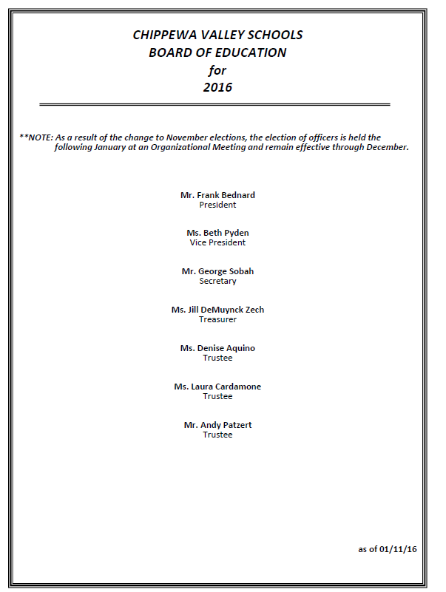

**WYANDOT MIDDLE SCHOOL CALENDAR 2015-16**

January 27 Secondary Students Attend in the AM Only (dismiss at 11:10)

Secondary Records Day (PM); End of Second Quarter

February 3 6th Grade Band Concert at 7 PM

February 10 Count Day

February 12 Mid-Winter Break at the End of the Day

February 22 Classes Resume

February 24 Early Release Day – All Students (dismiss at 1:46)

February 25 CAC Meeting—attend at 9 AM or 6:30 PM

March 2, 3 Middle School Parent/Teacher Conferences-Evening Only

Middle School Students attend All Day

Middle School Teacher Comp Time in the PM

March 4 Middle School Students in AM Only (dismiss at 11:10)

March 8 No School – All Students; Teacher Professional Development Day

~~March 23 Early Release Day – All Students (dismiss @ 1:46)~~ ER Day Canceled!

March 25 No School

April 1 Spring Break Begins at the End of the Day

April 11 Classes Resume

April 13 Spring Picture Day – 8:00 – 1pm

End of Third Quarter

April 14 CAC Meeting—attend at 9 AM or 6:30 PM

~~April 27 Early Release Day – All Students (dismiss at 1:46)~~ ER Day Canceled!

~~May 11 Early Release Day – All Students (dismiss at 1:46)~~ ER Day Canceled!

May 19 CAC Meeting—attend at 9 AM or 6:30 PM

May 27 Students Attend in the AM only; Teacher Professional Development in PM

(dismiss at 11:10)

May 30 Memorial Day – No School – All Students

June 2 Band Concert

June 9 Choir Concert for community 7 PM

June 10 Choir Concert 8-9 AM

June 10 Jazz Band ice cream social 7 PM

June 15 Last Day of School for Students

Students Attend in the AM Only (dismiss @ 11:10)

End of 4th Quarter – Secondary

***Watch for future updates in the 4th quarter newsletter.***

Our school's vision:

***All Wyandot Middle School students will reach their full potential.***



***Our School's Mission:***

***The Wyandot community is committed to providing a challenging, relevant, and diverse curriculum in a safe, stimulating environment, enabling each student to become a life-long learner and a contributing member of society.***