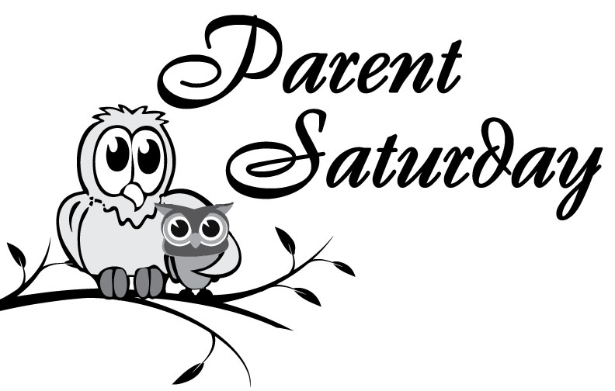
Is Coming on April 25th!
22 Workshops for Parents of
Elementary Through High School Children

Sponsored by the
Chippewa Valley Coalition for Youth and Families and Chippewa Valley Schools

$5 Fee for Parents
Free Childcare for Children 4 – 10 Years
(Fun activities and snacks for children)
Scholastic Book Fair and Community Resource Displays

Saturday, April 25, 2015
8:30 am to 12 noon
Chippewa Valley High School (Main Building)

Come and Learn About….
How to Talk So Kids Will Listen & Listen So Kids Will Talk
Summer Fun - Ways to Keep/Improve Your Child's School Skills
Parenting with Love and Logic
Navigating the TWEEN Years
Helping Your Child Transition to Middle School
Guidelines for Parents: How Old is Old Enough?
For Dads Only
Mothers and Daughters – A Very Special Relationship
Let’s Relax! Yoga and Relaxation Techniques for Parents
The Tech Savvy Parent
Navigating the Teen Years
Brain-Based Development and More!

Registration Information Will Be Available in March

