Come join us at Macomb’s
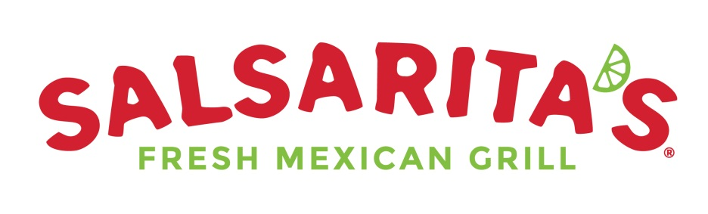
18325 Hall Rd.
On November 14^{th,} 2018
And help raise money for
IROQUOIS STUDENT COUNSEL
Be sure to bring this flyer a present it to the cashier and 20% of our sales will go to benefit Iroquois!
Come join us at Macomb’s
18325 Hall Rd.
On November 14^{th,} 2018
And help raise money for
IROQUOIS STUDENT COUNSEL
Be sure to bring this flyer a present it to the cashier and 20% of our sales will go to benefit Iroquois!

