CHIPPEWA VALLEY SCHOOLS
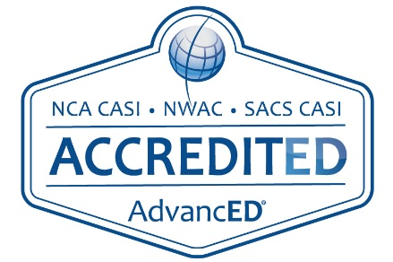 | HURON ELEMENTARY SCHOOL  Kelly Shock, Principal  15800 Terra Bella  Clinton Township, MI 48038  (586) 723-5800 OFFICE  (586) 723-5801 FAX
October 26, 2018

Dear Huron Families,

Ensuring the safety of our students and staff is our top priority. I am writing today to provide you with important information and facts regarding the upcoming Safe Schools, Strong Schools Proposal. On November 6 Chippewa Valley residents will be asked to vote on a bond proposal designed to keep our kids safe. This proposal will allow us to fund necessary improvements without raising taxes by extending our current bond repayment millage.

The Safe Schools, Strong Schools proposal would:

*Allow us to fund necessary security enhancements in our building, including the addition of a panic button in our school office, new security cameras (some of our cameras in the district are 10 years old and out of warranty), new door locks, and improved interior corridor systems.

*Replace buses that are oldest in the fleet, and replace roofing, plumbing and mechanical systems throughout the district to keep students safe, warm and dry.

*Enhance our classroom technology to give our students real life, hands-on experiences and a head start on careers through state-of-the-art instructional technology and increased access to Career and Technical Educational programs so our students can compete for the jobs of tomorrow.

There are many improvement projects planned for our school. Here are just a few……
*Renovations to Huron’s parking lot.
*Repair roofing.
*Replace old playground equipment.

I urge you to visit our website and click on the Safe Schools, Strong Schools link to see a complete list of improvements and to learn more information about this important proposal. I also invite you to contact me at (586)723- 5800 with any questions you may have.

Chippewa Valley has a proven track record of fiscal responsibility. We work hard to be good stewards of your taxpayer dollars and to provide your children with an outstanding education.

Together we can continue this tradition of excellence.

Respectfully,

Kelly Shock
Huron Principal

